Jingle Into Junction Scheduled for Dec. 8
GRAND JUNCTION WINTER 2019 NEWSLETTER
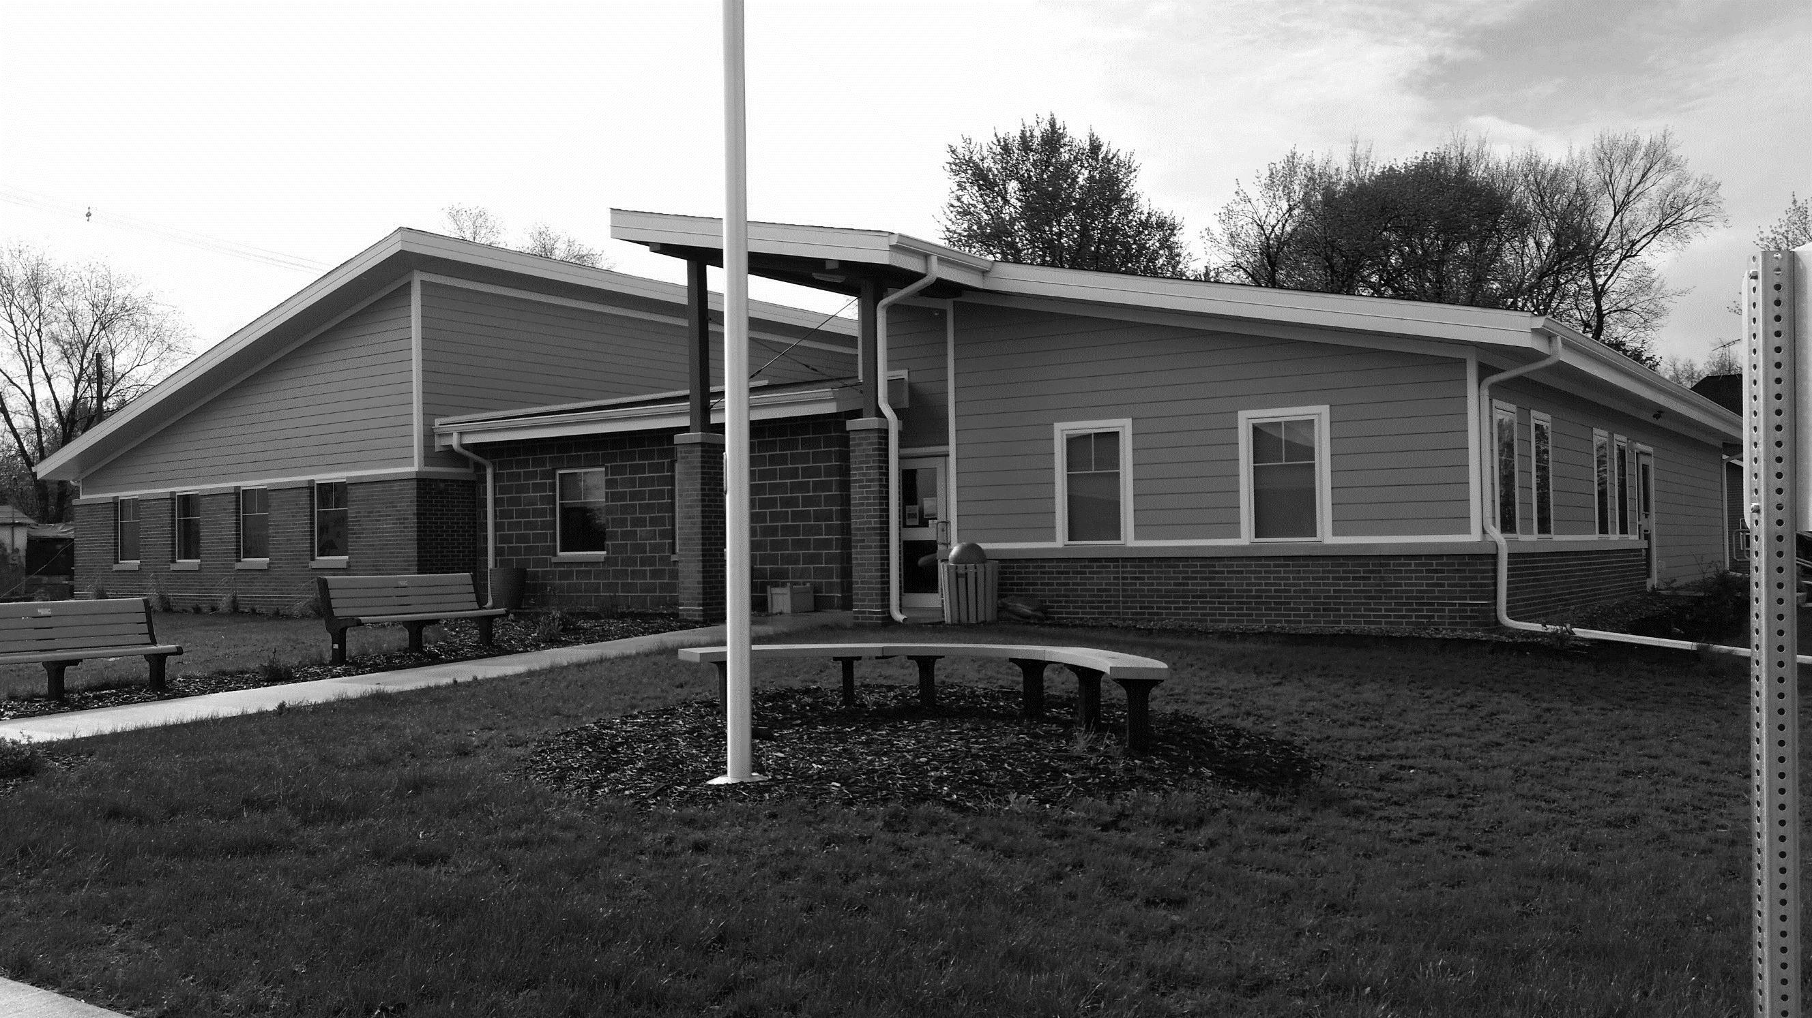

Join us as we kick off the holiday season at our annual Jingle Into Junction holiday celebration at the Community Center on Sunday, Dec. 8, from 5–6:30 p.m.
GJ Horizons will offer a delicious soup supper and sponsor a silent auction of fun and interesting items and gifts. The GJ Library will host Mrs. Claus’s bake sale, the Fire and Rescue team will host Santa and have a turkey give-away, and the 4th Annual Trees, Wreaths & Stockings festival will showcase a display of trees, wreaths, and stockings, some of which can be purchased.

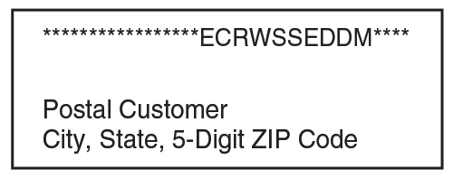
Also, the Naked Ladies Garden Club will offer its 2020 calendars for sale along with garden crafts and décor. We’ll also have a special tree-lighting event you won’t want to miss.
Plus, the Iowa State Design class will have up to 10 possible designs for the former school site on display. You’ll

have a chance to review them all and make comments.
This community celebration is a great way to kick off the holiday season and a fun night for everyone in town to get together.
Proceeds from the tree festival will go to Grand Junction’s 2020 celebration; proceeds from the soup supper free will offering and silent auction will be used to fund upcoming Horizons-sponsored community projects.
Recycling Changes Coming in 2020
The Greene County Recycling Board has met several times to work out a recycling solution after Genesis Development ended its recycling services.
Through the end of this year, West Central Iowa Solid Waste Management Association in Carroll will pick up curbside recyclables as usual in Grand Junction.
Curbside recycling will end on Dec. 31, 2019. Starting in 2020, recyclables will need to be taken to the city’s drop-off box.
Acceptable recycling items are food and beverage glass jars & bottles, steel cans, plastic containers, newspapers, office paper, magazines, catalogs, cereal boxes and corrugated cardboard.
All containers should be emptied and cleaned. You can go to the website at www.westcentralsolidwaste.com for more information about recycling.
New Mayor, Council Members Elected
Grand Junction residents elected three new leaders on Nov. 5.
Write-in candidate Jerry Herrick was elected mayor and will serve a two-year term beginning Jan. 1, 2020. Brian Mount and Chad Wilson were elected as City Council members. They will each serve a four-year term on council beginning Jan. 1, 2020.
Many thanks go to Meladee Graven and Alan Robinson for their service as council members and to Brock Lyons for his mayoral leadership.. Thanks also to all who voted and congratulations to our newly-elected town leaders. Working cooperatively together with them will help us move Grand Junction forward!
Reminders for 2020
- Winter Reminders: City code requires all vehicles to be moved off city streets and parking during snow emergencies. The snow ordinance emergency parking ban will take effect & last through the duration of a storm and for 48 hours afterwards. You have 24 hours to clear your property sidewalks to avoid being charged clearing costs.
- Dog licenses for 2020 are available for $5. Pet owners are responsible for registering their pet every January. Owners must provide a current vaccination. Dogs must wear their tag. All animals must be secured at all times, either in a fenced yard, tethered in a place so they cannot reach sidewalks or roadways, or on a leash with a person capable of controlling the pet holding the leash.
- Golf Cart permits are $15 again for 2020. Please register your cart before you use it on Grand Junction streets in 2020.
New in Town?
A number of folks have moved into our little town in the last year. If this group includes you, we’d like to welcome you to your new hometown!
Grand Junction’s Horizons will send a representative or two to your home with some “welcome” gifts and helpful information on where to go, who to call, and how to get things done around here.
If you’ve moved to GJ in the last year, please contact City Hall (see below) and let us know so we can set up a good time to meet and greet you!



Contact City Hall at 515-738-2585 or grandjct@iowatelecom.net.
Office hours are Monday ─ Friday, 9 am to noon or by appointment
www.grandjunctioniowa.org

