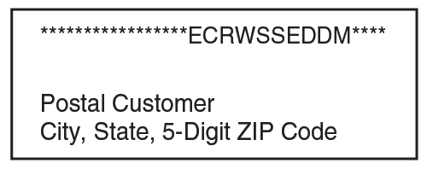
Community Unites for Derecho Cleanup
GRAND JUNCTION AUTUMN 2020 NEWSLETTER
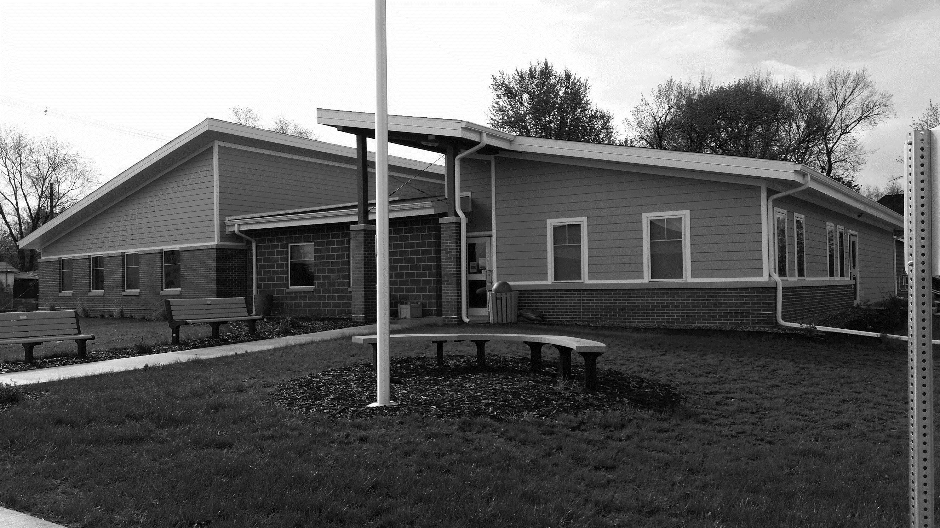
The August 10 derecho had barely exited the town before the sounds of chain saws began echoing around Grand Junction as cleanup began after the unexpected storm powered its way through.
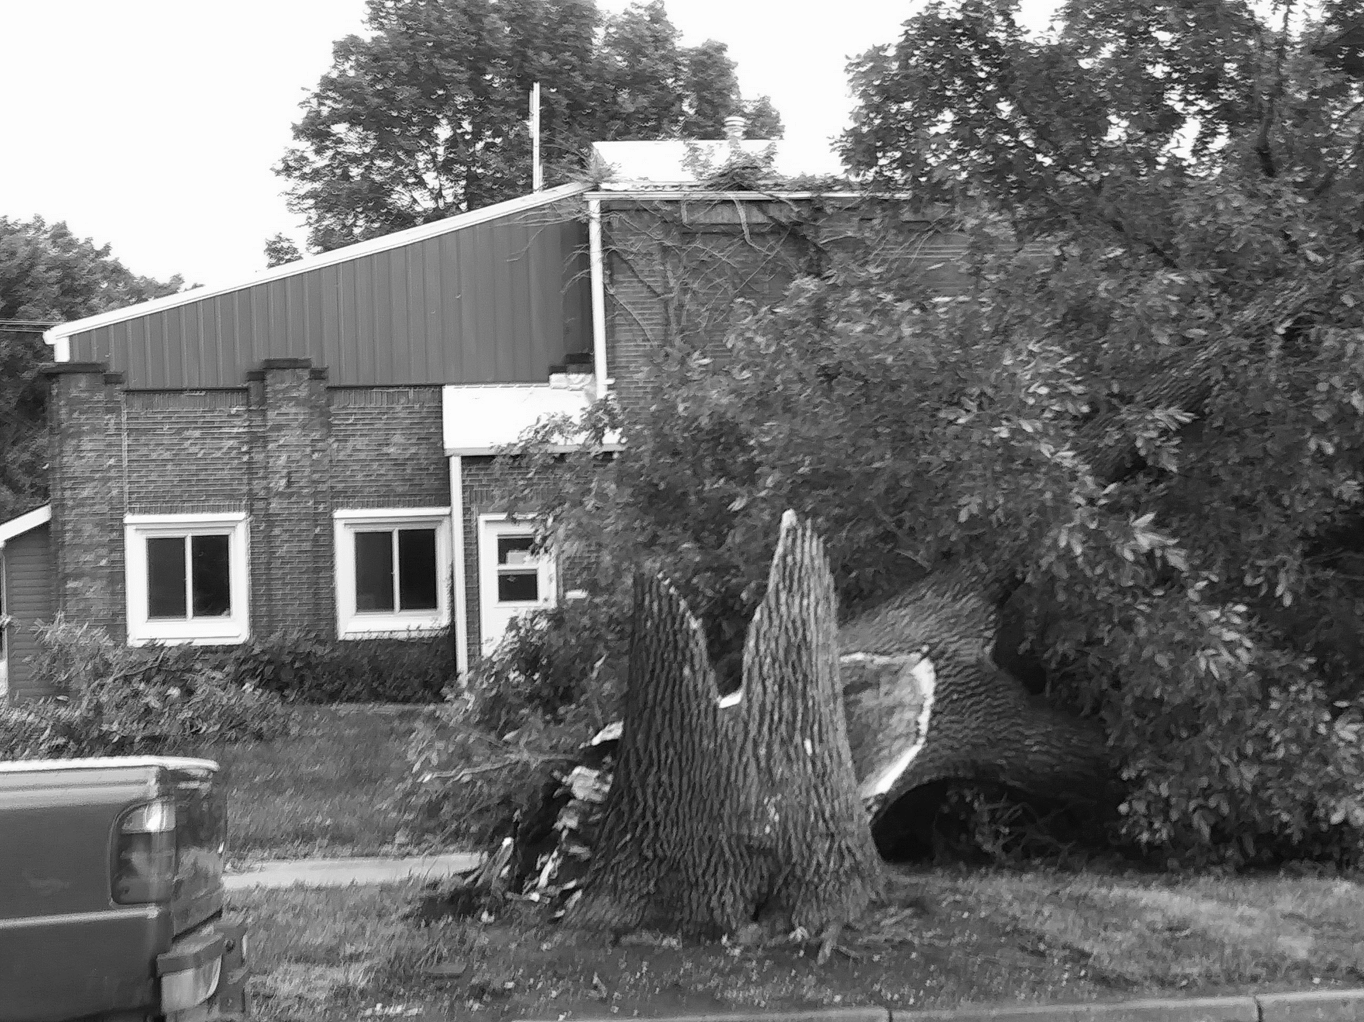
Residents came out of their homes mostly unscathed but clearly stunned by the devastation surrounding them. Our small town lost big limbs, many branches, and dozens of trees, some of which were as old as the town. Parts of town lost power but the Municipal Light Plant, with help from other utility workers, had most electricity restored by nightfall.

Community volunteers worked to clear debris from streets, yards and driveways and off buildings. Almost everyone who was able helped cut up and/or haul away trees and branches to the dump for the next several weeks. The brush pile in the town dump is now over 240 feet long, 120 feet wide, and 35 feet high.
Community Park Cleanup Day Saturday, Oct. 17
Among the hardest hit areas was the park, with many trees down and branches covering the ground. The park has been closed since the derecho due to unsafe conditions from the damage.
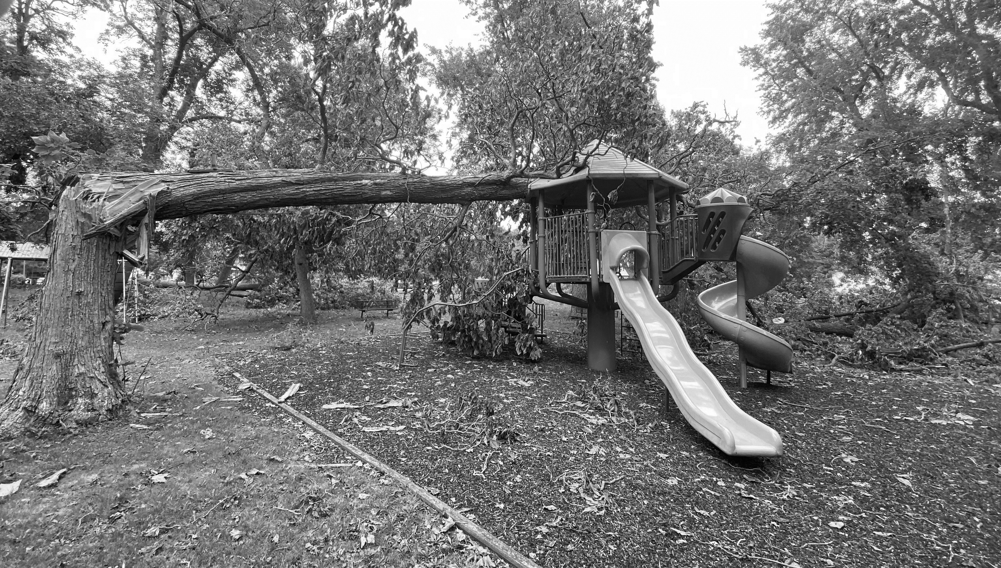
The GJ City Council has designated Saturday, Oct. 17, from 9 a.m. to 3 p.m. as Park Cleanup Day. Everyone is encouraged to come, even for an hour or two, to pick up sticks, rake, and help clean up the park so it can reopen for everyone’s enjoyment again.

It’s Been Quite a Year!
What with the coronavirus pandemic keeping folks at home, the extreme drought drying out area crops, and the August derecho destroying trees and fields, Grand Junction has had quite a 2020. But it hasn’t been ALL bad…
So what has the city be able to get done so far this year?
In April the city received a grant from the Greene County Community Foundation to resurface the sports court at 12th and Hager with a new concrete slab. An earlier grant was used to clean up the area, upgrade landscaping and lighting, and install new backboards and poles. The resurfacing was done in June and is an improvement to the overall school site.
In May, City Council approved installation of a sidewalk between the Community Center and the storage shed with financial contributions from Lions Club and Horizons.
Grand Junction held a successful citywide clean-up day on Saturday, June 27. The later-than-usual date meant fewer helpers but we managed to pick up even more junk than last year. Thanks go to all the hard-working volunteers who pitched in and picked up as well as to the Ladies Club for the rolls and sandwiches to keep everyone’s energy up.
Despite the uncertain times, GJ opened the municipal pool on July 1. The pool had very steady attendance as well as two pool parties booked from Perry. Overall, it was a much better year than expected, and the pool crew made extra efforts in following coronavirus guidelines in cleaning and keeping people safe.
Utilizing leftover grant funds, in August the city purchased LED lights to be installed all along Main Street as soon as the Light Plant can get them installed.
Contact City Hall at 515-738-2585 or grandjct@iowatelecom.net.
Office hours are Monday ─ Friday, 9 am to noon or by appointment
www.grandjunctioniowa.org
In September, the town got its planned road repairs accomplished. Sta-bilt Construction seal-coated 20 blocks of city streets, focusing on areas of 10th, 11th, 12th, 15th, and 19th streets. Work also began on replacing sidewalks along Main Street in front of the Coffee Corner, the library, and the museum. This work will be continuing for the next few weeks.
Absentee Ballots Available
The General Election is Tuesday, Nov. 3, and Absentee Ballot Request Forms have been mailed to all Iowa registered voters. If you want to receive a ballot by mail, fill out the Absentee Ballot Request form and return it to the Greene County Auditor by Oct. 24 at 5 p.m.
For more information or to track your ballot, go to voterready.iowa.gov or call the Greene County Auditor at 515-386-5680.
Trunk or Treat Set for Oct. 31
At a special meeting, the City Council voted to tentatively hold the town’s annual Trunk or Treat Halloween event on Saturday, Oct. 31, with some changes to ensure everyone’s safety.
For example, cars parked along Main Street will be separated by spaces; tables should be set out by the trunk for grab-and-go treats, and treats should be put into separate containers or bags. We want to keep everyone safe!
Jingle Into Junction Ideas
Horizons has been meeting the last couple of months to discuss ideas on how to maintain our town’s traditional Jingle Into Junction in December while keeping folks safe and socially distant. A decision will be made by November.

